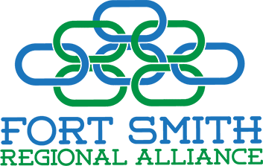

Fort Smith Regional Alliance

BOARD MEeting
LOCATION: | PEAK INNOVATION CENTER  5900 painter lane  fort smith, ar 72903
Date: | SEPTEMBER 9, 2026
Time: | 11:30 AM – 1:00 PM

- inVOcation Mayor gary baxter
- WELCOME/Call to order eddie lee herndon
- Approval of Minutes – dECEMBER 2025 eddie lee herndon
- APPROVAL OF FINANCIALS eddie lee herndon
- CDI SCHOLARSHIP ReCIPIENT PRESENTATIONS phyllis thompson
Shannon newerth-henson
- GUEST SPEAKER – arkansas highway COMMISSIONER Keith gibson
- Other Business EDDIE LEE HERNDON
- Adjournment for tour of i-49 site EDDIE LEE HERNDON

tHANK YOU TO OUR LUNCH SPONSOR
PETIT JEAN REGIONAL FOUNDATION!

